**PRESS RELEASE**

**22.07.24**

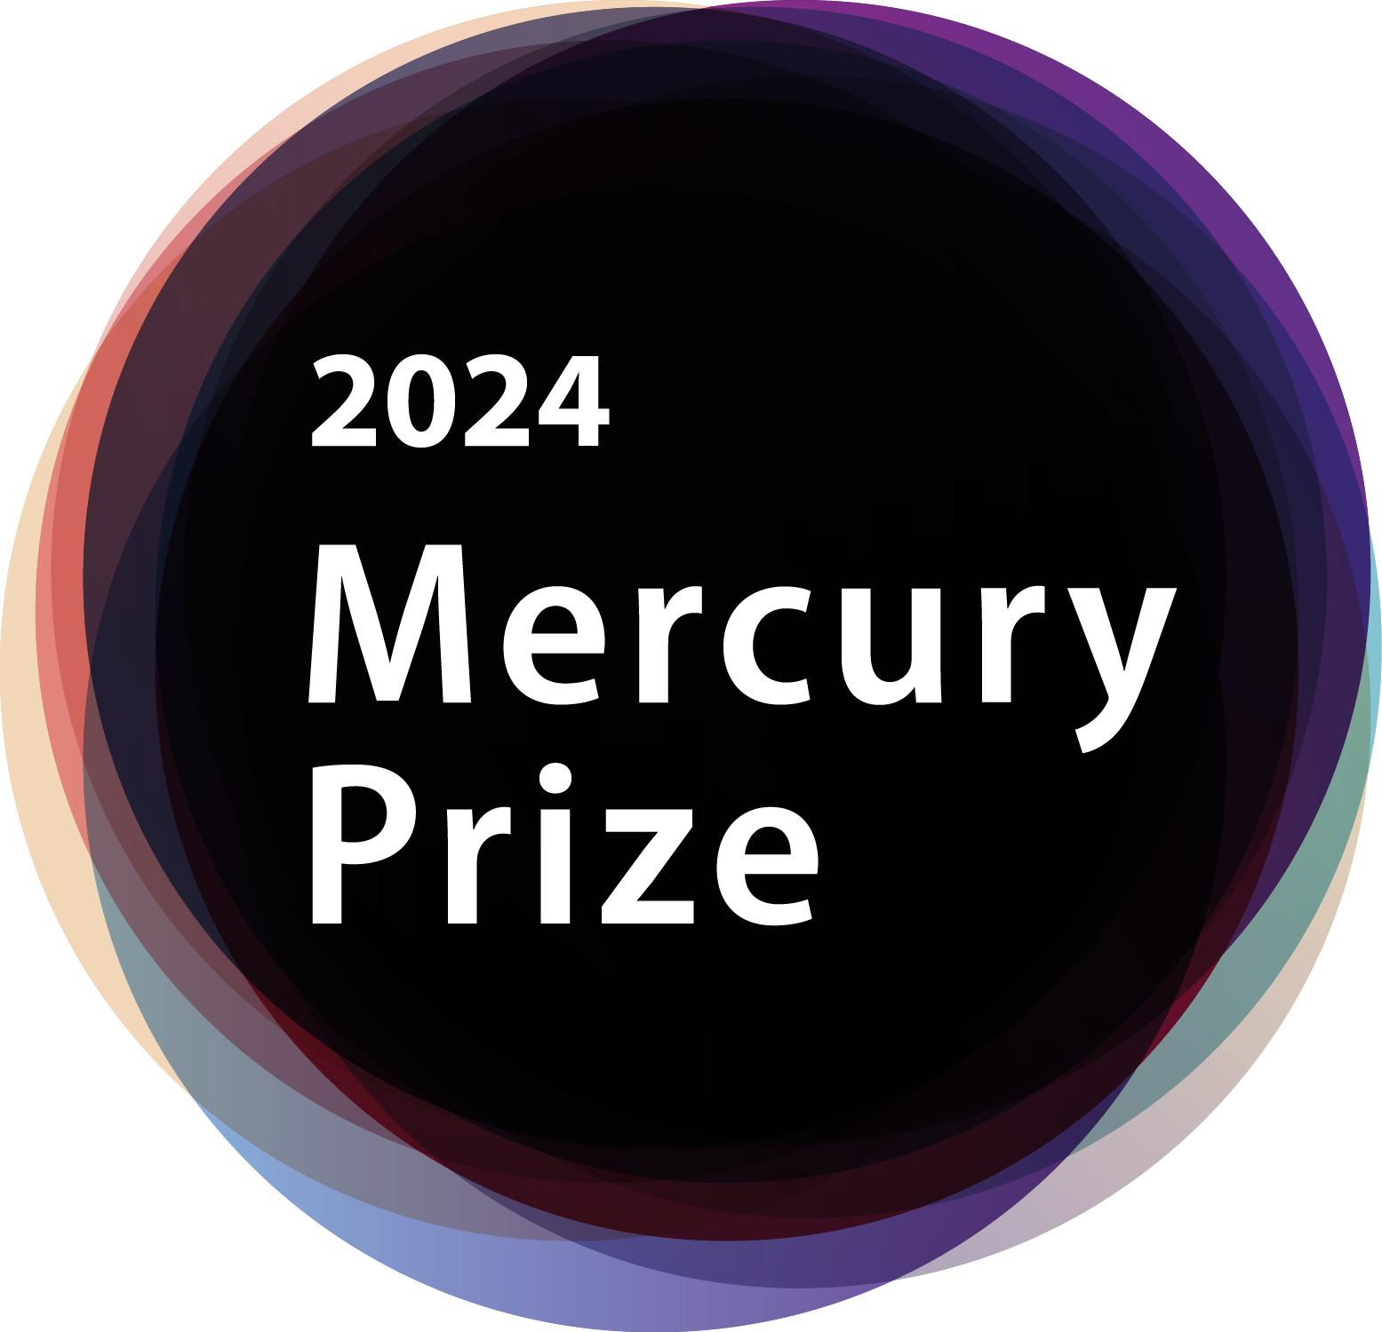

**2024 Mercury Prize ‘Albums of the Year’ to be announced Thursday 25 July from 11am BST**

* **BBC Music partnership continues, with the 12 ‘Albums of the Year’ revealed live on BBC Radio 6 Music**
* **2024 Judging Panel confirmed**
* **Overall winner to be revealed in September**

**The Mercury Prize 12 ‘Albums of the Year’** will be revealed on **Thursday 25 July,** announced exclusively live on **BBC Radio 6 Music** from 11am by Tom Ravenscroft (standing in for Mary Anne Hobbs 10.30am-1pm).

**BBC Music** continue their long-standing broadcast partnership, which sees programming on BBC Four and 6 Music, celebrating all 12 albums.

**The Mercury Prize** recognises and celebrates the ‘Albums of the Year’, establishing a reputation for highlighting the work of both exciting emerging talent and more established bands and artists. The 12 ‘Albums of the Year’ are chosen by an independent judging panel and recognise artistic achievement across a range of genres. Albums by British and Irish artists with a UK release date between 15 July 2023 and 12 July 2024 are eligible for the 2024 Prize.

The **2024 Mercury Prize** judges are: **Danielle Perry** – Broadcaster & Writer; **Jamie Cullum** - Musician & Radio 2 Broadcaster; **Jamz Supernova** – 6 Music Broadcaster & DJ; **Jeff Smith** - Head of Music, Radio 2 & 6 Music; **Lea Stonhill** – Music Programming Consultant;  **Mistajam** – Songwriter, DJ & Broadcaster; **Phil Alexander** – Creative Director, Kerrang!/Contributing Editor, Mojo; **Sian Eleri** – Radio 1 Broadcaster & DJ; **Will Hodgkinson** - Chief Rock & Pop Critic, The Times; **Sophie Williams** – Music Writer & Broadcaster. The Chair of the judging team is **Jeff Smith**.

The overall winner of the 2024 Mercury Prize will be revealed in September with the Prize’s broadcast partner BBC Music providing exclusive television and radio coverage as well as online and social media support as part of the wider media and retail engagement around all the 12 albums. This year, other extensive promotional activity will replace the usual live performance event element of the Mercury Prize – details to be announced closer to the time.

**Dr Jo Twist OBE, CEO of the BPI**, home to The Mercury Prize, said:

*“The Mercury Prize is a cherished part of our cultural landscape, celebrating the art of the album and recognising the exceptional creative achievements of diverse British and Irish artists across the many different genres that make up our thriving and global-facing music scene.*

*“We are delighted to deepen our relationship with our long-term partner BBC Music to promote the Prize across its networks, including its national broadcast and digital channels, to ensure the greatest possible impact and profile as part of a wider campaign to support the artists who produced the 12 Albums of the Year.*

*“For the 2024 Mercury Prize we will work imaginatively with the BBC to deliver a premium programme of music content and digital engagement that will, as ever, benefit all 12 artists in reaching a wider audience, providing an important platform for their evolving career and musical journey.”*

As part of its ongoing commitment to supporting UK recorded music, renowned British premium audio brand, **Bowers & Wilkins**, continues as long-term official audio partner of the Mercury Prize. At the forefront of music creation for over 40 years, it is uniquely placed to help the Mercury Prize celebrate the album format and the creative achievements of the 12 artists.

Further information:

Media Enquiries: DawBell – 0203 327 7111

Katie Baptie (print) - katie.baptie@dawbell.com

Maria Barham (radio) - maria.barham@dawbell.com

Pippa Evers (TV) – pippa.evers@dawbell.com

Charlie Brun (online) – charlie.brun@dawbell.com

BBC Press Office: sarah.hall1@bbc.co.uk

**Note for Editors**